

CLIENT: | Thelen Kia | PHONE #:
SPOT: | THEL-KI-T201101 Kia November | FAX # :
LENGTH: | :30 | SALES REP: | Larry H.
DATE: | 11/11/2020 | PRODUCER | A. Dennis

GRAPHICS | Video | AUDIO
Thelen Kia Logo  Euclid Ave. - Bay City www.ThelenKia.com  Kia Command The Season (logo)  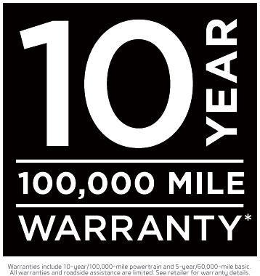  Warranties include 10-year/100,000-mile powertrain and 5-year/60,000-mile basic. All warranties and roadside assistance are limited. See retailer for warranty details.  2021 Kia Forte LXS  Purchase From Just $17,995  VIN # 3KPF24ADXME266653. May require approved credit. No security deposit required. Tax, title and license fees extra. See Thelen Kia for details. Ends November 30th, 2020.  2021 Kia K5 LXS  Lease From Just $229/mo  For 36 Months $995 Due At Signing  VIN # 5XXG14J24MG027287. Lease 10,000 miles per year for well qualified buyers with approved credit. $995 due at signing. Taxes extra. No security deposit required. See Thelen Kia for details. Ends November 30th, 2020.  Think Thelen (Logo)  Kia (logo)  Euclid Ave. - Bay City www.ThelenKia.com | GFX: Kia Logo  GFX: Various 2021 Kia SUV Models  Drone Video: dealership inventory  GFX: 2021 Kia Forte LXS Photo  GFX: 2021 Kia K5 Photo  GFX: Logo Animation  Video: Thelen Kia Dealership drone footage | Announcer: (:)  Save MORE at Thelen Kia in Bay City!  Don’t miss Kia’s Command The Season Event! Save on our new lineup of winter ready vehicles!  Combined with Kia’s 10-year/100,000-mile limited warranty…  You’ll get more vehicle for your money!  Right now, buy a new Kia Forte LXS for just $17,995!  Or lease a new Kia K5 LXS from just $229 a month!  Hurry to Thelen Kia - Euclid avenue in Bay City! Online at thelenkia.com  Getting you more for your money...  because It’s the Right Thing to Do!

